Software Testing Assignment

1. What is SDLC?

ANS. SDLC – Software Development Life Cycle. ●SDLC is a structure imposed on the development of a software product that defines the process. For planning, implementation, testing, documentation, deployment, and ongoing maintenance and support. There are a number of different development models.

1. What is agile methodology?

ANS. Agile SDLC model is the combination of iterative and incremental model with focus on process adaptability and customer satisfaction by rapid delivery of working software product.

1. What is SRS?

ANS. SRS-Software Requirements Specification.

●A software requirements specification (SRS) is the complete description of the behavior of the system to be developed.

4. What is oops?

ANS. OOP-Object Oriented Programming.

●Identifying objects and assigning responsibilities to these objects.

5. Write Basis Concepts of oops.

ANS. Concepts of OOP

●Object

●class

●Encapsulation

●Inheritance

●Polymorphism

●Overriding

●Overloading

●Abstraction

6. What is object?

ANS. To access all the properties of an class accept private.

7. What is class?

ANS. Class is an collection of data member (variables), member function (process, method) with its behavior.

8. What is encapsulation?

ANS. Wrapping up of data into a single unit i.e. :private your data member or member function.

9. What is inheritance?

ANS. Properties of parent class extend into child class : main purpose is : reusability , extensibility.

There are 5 types of inheritances:

1. Single
2. Multilevel
3. Hierarchical
4. Multiple
5. Hybrid.

10. What is polymorphism?

ANS. Ability to take one name having different forms.

There are 2 types:

1. Method overloading
2. Method overriding.

11. What is RDBMS?

ANS. RDBMS – Relational Database Management System.

●A database management system (DBMS) that incorporates the relational data model , normally including a Structured Query Language (SQL) application programming interface. It is a DBMS in which the database is organized and accessed according to the relationships between data item.

12. What is SQL?

ANS. SQL is the Structure Query Language, which is a computer language for storing, manipulating and retrieving data stored in relational database.

13. Write SQL commands.

ANS. 1. DDL : DATA Definition Language : create database, create table, truncate, use, etc…

2. DML : Data Manipulation Language : insert, update, delete.

3. DQL : Data Query Language : select

4. DCL/TCL : Data/Transactional Control Language : grant, revoke, commit, etc…

14. Draw usecase on online book shopping.

ANS.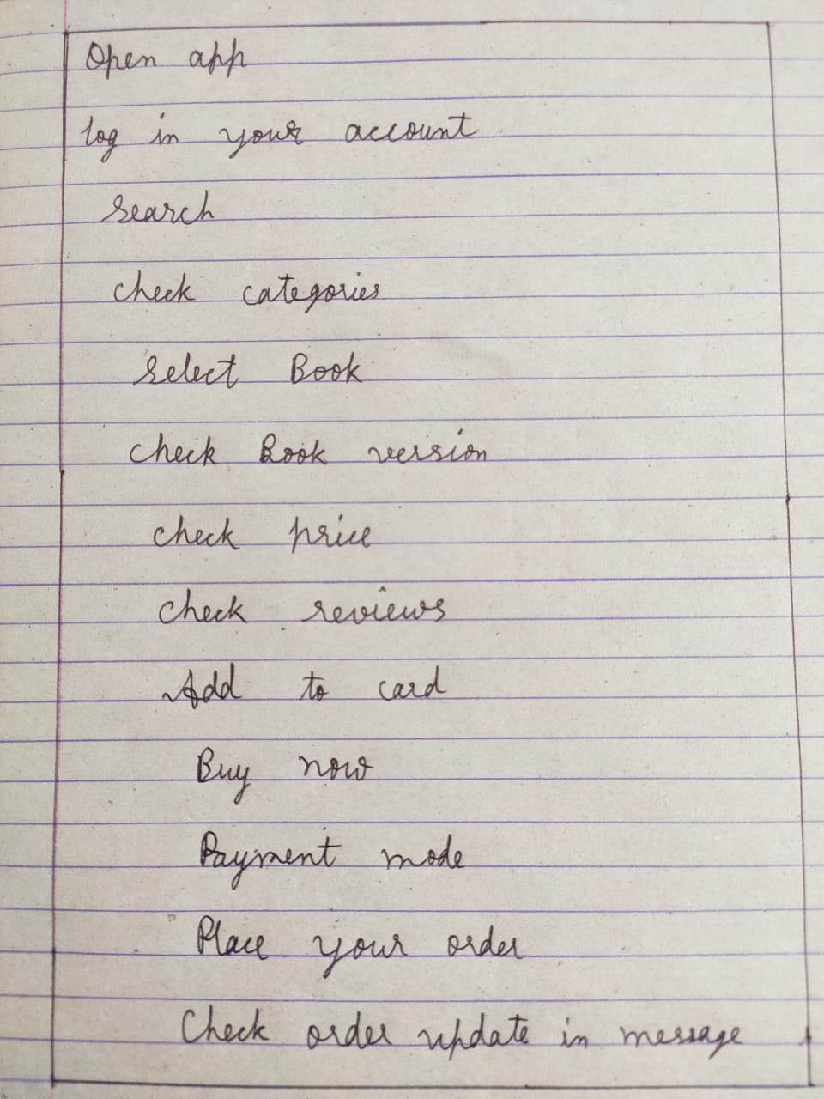

15. Draw usecase on online bill payment system (paytm).

ANS.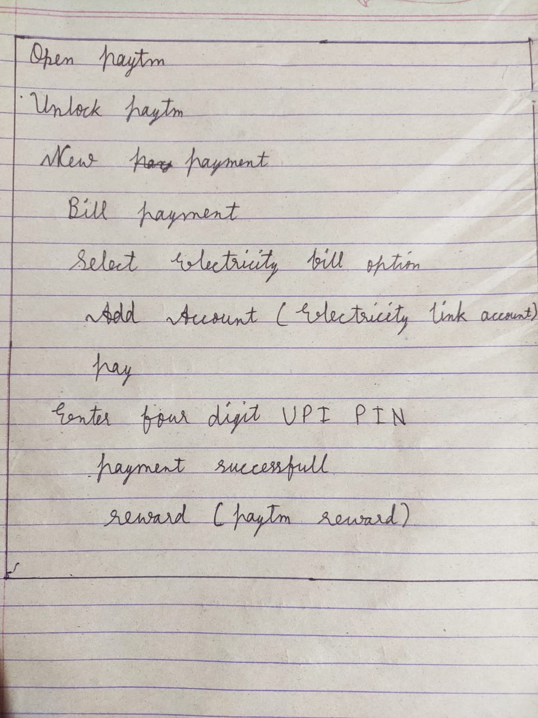

16. Write SDLC phases with basis introduction.

ANS. ●Requirements Collection: Usage scenarios.

: Although requirements may be documented in written form, they may be incomplete, unambiguous, or even incorrect.

●Analysis Phase: The analysis phase defines the requirements of the system, independent of how these requirements will be accomplished.

: This phase defines the problem that the customer is trying to solve.

●Design Phase: Design Architecture Document

: Critical Priority Analysis

: Implementation Plan.

●Implementation: In the implementation phase, the team builds the components either from scratch or by composition.

: For example, a component may be narrowly designed for this particular system, or the component may be made more general to satisfy a reusability guideline.

●Testing Phase: Simply stated, quality is very important. Many companies have not learned that quality is important and deliver more claimed functionality but at a lower quality level.

: Quality is a distinguishing attribute of a system indicating the degree of excellence.

●Maintenance Phase: Software maintenance is one of the activities in software engineering, and is the process of enhancing and optimizing deployed software (software release), as well as fixing defects.

: Configuration and version management.

17. Explain phases of the waterfall model.

ANS. ●Requirement Collection: Requirements definition usually consist of natural language, supplemented by (e.g., UML) diagrams and tables.

: Three types of problem can arise:

1.Lack of clarity

2. Requirements confusion

3. Requirements Amalgamation

: Types of Requirements:

1. Functional Requirements
2. Non-Functional Requirement.

●Analysis Phase: The requirement documentaries to capture the requirements from the customers perspective by defining goals.

: The architecture defines the components, their interfaces and behaviors.

: The design may include the usage of existing components.

●Design Phase: Design Architecture Document

: Test plan

: The requirement document must guide this decision.

●Implementation Phase: In the implementation phase, the team builds the components either from scratch or by composition.

: Implementation – Code

: Critical Error Removal.

●Testing Phase: A customer satisfied with the quality of a product will remain loyal and wait for new functionality in the next version.

: Quality is a distinguishing attribute of a system indicating the degree of excellence.

●Maintenance Phase: The developing organization or team will have some mechanism to document and track defects and deficiencies.

: configuration and version management.

: reengineering (redesigning and refactoring)

18. Write phases of spiral model.

ANS. Spiral Model is very widely used in the software industry as it is in synch with the natural development process of any product i.e. learning with maturity and also involves minimum risk for the customer as well as the development firms. Following are the typical uses of Spiral model:

●When costs there are a budget constraint and risk evaluation is important.

●Planning= determination of objectives, alternatives and constraints.

●Risk Analysis= Analysis of alternatives and identification/resolution of risks.

●Engineering= Development of the “next level” product.

●Customer Evaluation= Assessment of the results of engineering.

19. Write agile manifesto principles.

ANS. ●Individuals and interaction – in agile development, self-organization and motivation are important, as are interactions like co-location and pair programming.

●Working software – Demo working software is considered the best means of communication with the customer to understand their requirement, instead of just depending on documentation.

●Customer collaboration – As the requirements cannot be gathered completely in the beginning of the project due to various factors, continuous customer interaction is very important to get proper product requirements.

●Responding to change – agile development is focused on quick responses to change and continuous development.

20. What is join?

ANS. A join clause is used to combine rows from two or more tables, based on a related column between them.

21. Write type of joins.

ANS. There are four types JOINs in SQL:

● (INNER) JOIN: Returns records that have matching values in both tables.

●LEFT (OUTER) JOIN: Returns all records from the left table, and the matched records from the right table.

●RIGHT (OUTER) JOIN: Returns all records from the right table, and the matched records from the left side.

●FULL (OUTER) JOIN: Returns all records when there is a match in either left or right table.

22. Explain working methodology of agile model and also write pros. and cons.

ANS. ●Agile SDLC model is a combination of iterative and incremental process models with focus on process adaptability and customer satisfaction by rapid delivery of working software process.

●Agile method break the product into small increment builds.

●These builds are provided in iterations.

●Each iteration typically lasts from about one to three weeks.

Pros.

●Is a very realistic approach to software development.

●Promotes teamwork and cross training.

●Functionality can be developed rapidly and demonstrated.

Cons.

●Not suitable for handling complex dependencies.

●More risk of sustainability, maintainability and extensibility.

●Transfer of technology to new team members may be quite challenging due to lack of.

23. Draw usecase on online shopping product using COD.

ANS. 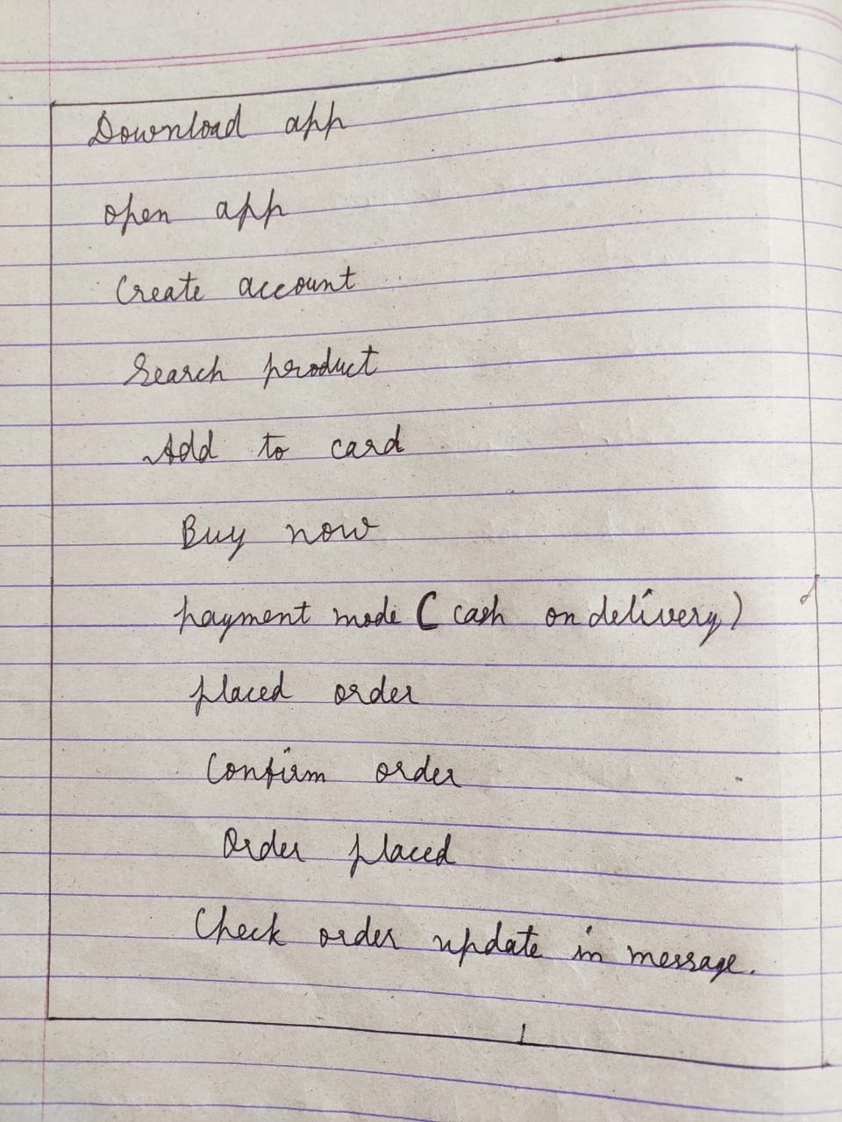

24. Draw usecase on online shopping product using payment gateway.

ANS. 